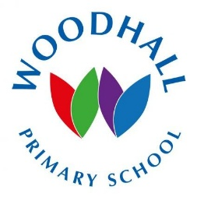
More than 95% of parents responded that they agreed or strongly agreed with the statement - my child is making good progress at this school.
The overwhelming majority of parents felt that the school took their views and concerns on board.
More than 95% of parents agreed or strongly agreed that their child was happy at the school with the same percentage stating that they felt the school kept them informed with their child’s progress.
Thank you for all your positive comments. It’s great to know when we get it right!
From the comments:
“Amazing school with amazing teachers and support staff”
100% of responses stated that they would recommend this school to others – thank you!
100% of parents felt that they were welcomed into the school when they visit.

